**12-piece Puzzle Template**

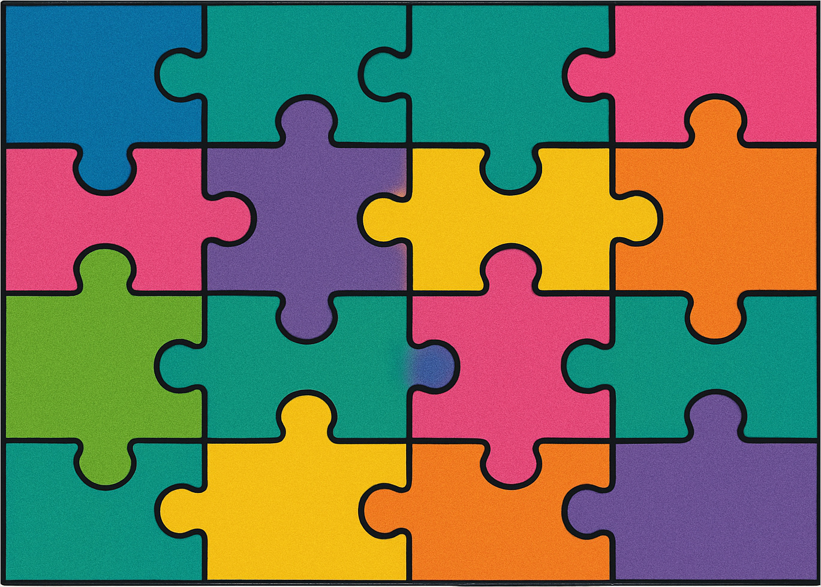

*ZellaTemplate.com*