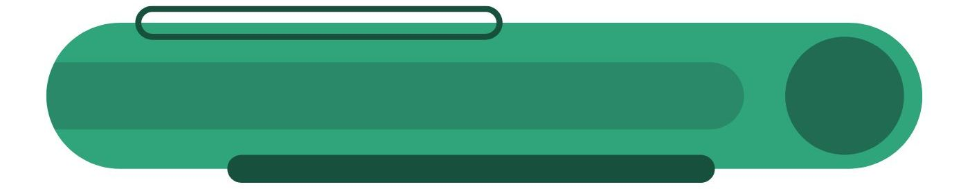**BEHAVIOR CONTRACT**

**This contract is made on:** [Date]

**Between:**

* **Individual (Name):** ________________________________________________________
* **Parent/Guardian (if applicable):** _____________________________________________
* **Teacher/Therapist (if applicable):** ____________________________________________

**1. Target Behavior(s)**

The following behavior(s) are the focus of this contract. These behaviors are expected to be observable, specific, and measurable.

|  |  |
| --- | --- |
| Behavior | Description |
| 1. |  |
| 2. |  |
| 3. |  |

**2. Goals (SMART)**

The individual agrees to achieve the following goals related to the target behavior(s):

|  |  |  |  |
| --- | --- | --- | --- |
| Goal | Description | Measurement | Target Date |
| 1. |  |  |  |
| 2. |  |  |  |

**3. Reinforcement (Rewards)**

The individual will earn the following rewards upon successfully meeting the goals above:

|  |  |
| --- | --- |
| Behavior/Goal Met | Reward |
|  | _ |
|  | _ |

**4. Consequences**

If the goals are not met, the following consequences may be applied:

|  |  |
| --- | --- |
| Behavior Not Met | Consequence |
|  | _ |
|  | _ |

**5. Timeline and Review Dates**

* **Contract Start Date:** ____________________
* **Initial Review Date:** ____________________
* **Final Review Date:** ______________________
* **Frequency of Progress Checks:** ☐ Daily ☐ Weekly ☐ Bi-weekly ☐ Other: ___________

**6. Review and Adjustments**

* This contract may be adjusted during review meetings based on progress.
* Changes must be agreed upon and signed by all parties.

**7. Signatures**

By signing this contract, all parties agree to the terms listed above and commit to supporting the individual in achieving the outlined goals.

**Individual:**  ___________________________ **Date:** ____________

**Parent/Guardian:**  ______________________ **Date:** ____________

**Teacher/Therapist:**  _____________________ **Date:** ____________