

**Dear Father Christmas,**

My name is **Lily Thompson**, and I am **8 years old**. I live at:  
**42 Maplewood Lane, Bristol, UK**.

I hope you, the reindeer, and the elves are all doing well and staying warm at the North Pole. Thank you so much for the gifts you brought me last year—my favorite was **the pink scooter**! I ride it almost every day when it's sunny.

This year, I’ve been **helping my little brother with his homework and keeping my room clean**. I’ve also tried really hard to be polite and listen to my parents.

Here is my Christmas wish list, in order of what I would like the most:

1. **A LEGO Friends Heartlake City set**
2. **A unicorn onesie**
3. **A sketchbook with colored gel pens**
4. **"The Magic Puppy" book series**

If any of these gifts are too expensive or hard to find, I understand—I’ll still be very happy with whatever you bring me.

I hope you and your team have a safe and happy journey on Christmas Eve. I’ll leave out some **chocolate chip cookies and a glass of milk** for you and **carrot sticks** for the reindeer!

Merry Christmas!

**Love,**  
**Lily**

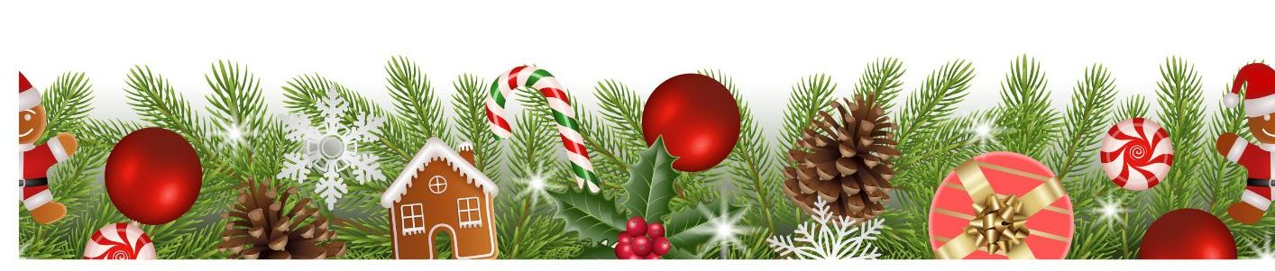

*ZellaTemplate.com*