**Dear Father Christmas,**

Hello! My name is [Your Name], and I hope you, the elves, and the reindeer are all doing well at the North Pole. I've been so excited for Christmas this year and wanted to write you a little letter.

First of all, thank you so much for the wonderful gifts you brought me last year. I really loved [mention a favorite gift or memory]! I've been trying my best to be good this year—helping at home, being kind to others, and working hard at school.

This Christmas, I would be so happy if you could bring me [insert gift wish #1], [gift wish #2], or maybe even [gift wish #3] if the elves have time to make it!

Of course, I know Christmas is about more than just presents. I love spending time with my family, listening to festive music, and seeing all the twinkling lights. I hope you and everyone at the North Pole have a cozy and joyful Christmas too.

Please give my love to Mrs. Claus, the reindeer (especially Rudolph!), and all the hardworking elves.

Merry Christmas and safe travels on Christmas Eve!

With love,  
[Your Name]  
[Your Age] (optional)  
[City/Town, Country] (optional)

*ZellaTemplate.com*

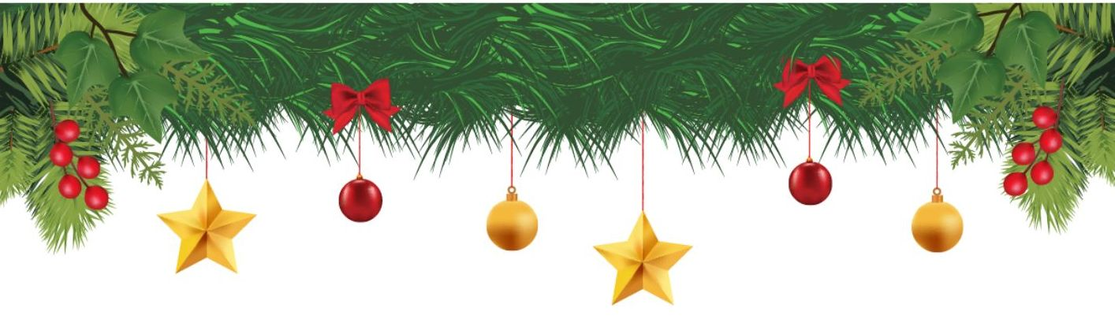

**Example:**

**Dear Father Christmas,**

My name is Emily, and I’m 7 years old. I hope you, Mrs. Claus, and all the elves are keeping warm and happy at the North Pole. I bet the reindeer are practicing their flying for the big night!

Thank you so much for the presents you brought me last year. I loved the pink roller skates and the art set—it was just what I wished for! I’ve tried really hard to be good this year. I’ve been helping my little brother tie his shoes, feeding our cat Mr. Whiskers every day, and always saying “please” and “thank you.”

This year, I would really love a fluffy panda stuffed animal, a sparkly purple diary with a lock, and maybe a LEGO fairy castle if there’s still room in your sleigh.

I’ve already hung my stocking on the fireplace, and we’re going to leave out some chocolate chip cookies and a big glass of milk for you. We’ll also leave a few carrots for the reindeer—Dasher and Dancer must get hungry too!

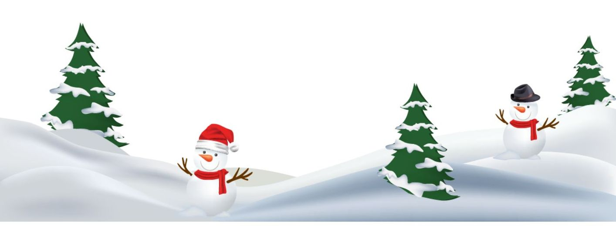I hope you have a wonderful Christmas, and thank you for making this time of year so magical.

Lots of love,  
Emily  
Age 7  
London, England

*ZellaTemplate.com*