**Pinewood Derby Car Template**

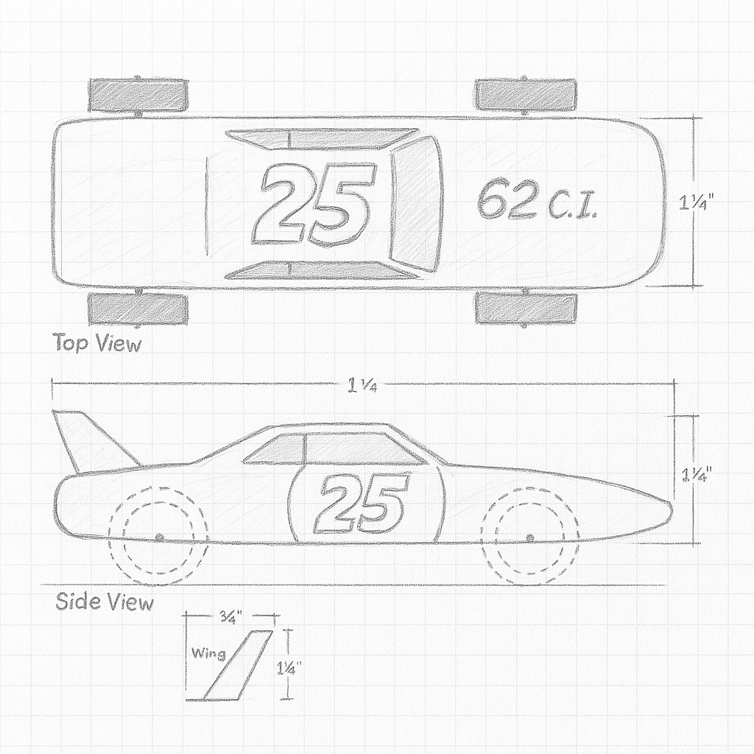

Designed by **ZellaTemplate.com**

**Pinewood Derby Car Template**

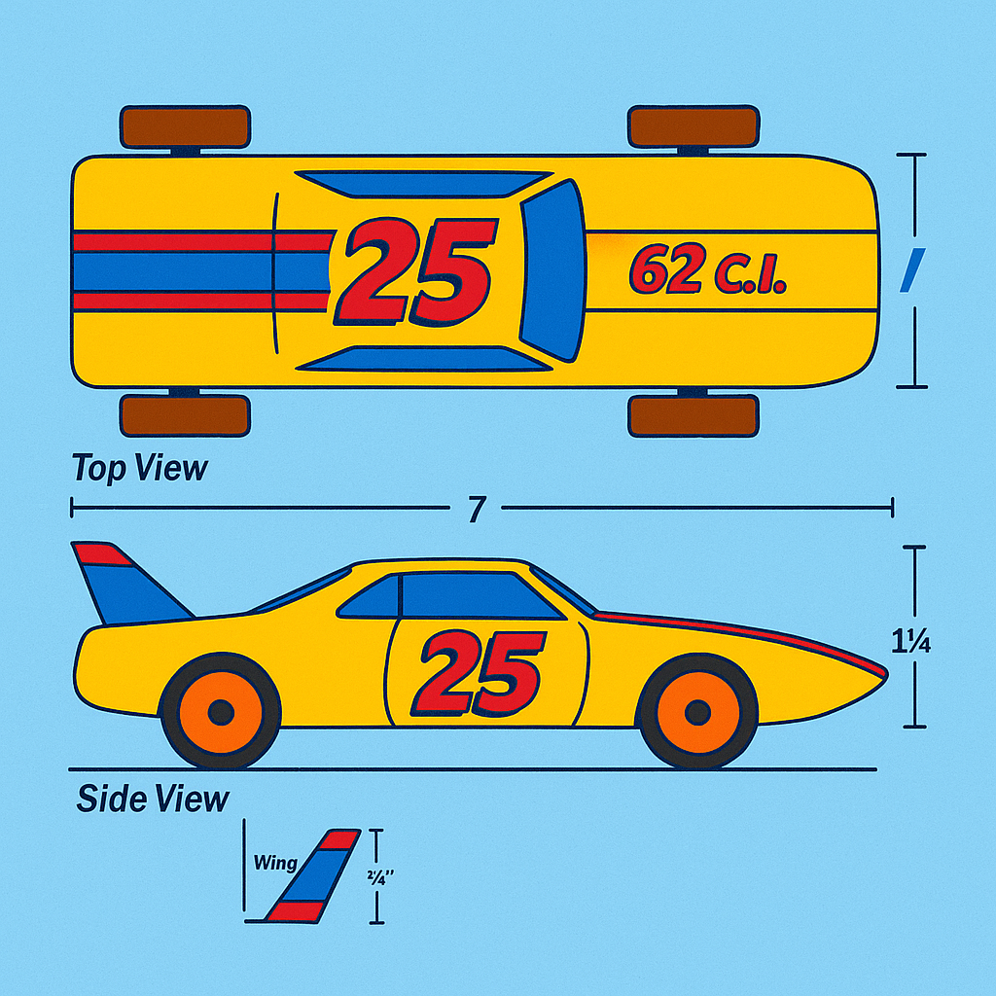

Designed by **ZellaTemplate.com**