# C:\Users\user\Downloads\White and Blue Modern Minimalist Blank Page Border A4 Document.jpgTemperature Log Sheet

Location/Facility: __________________________

Department/Area: __________________________

Supervisor: ________________________________

Date Range: From __________ To __________

## Storage/Equipment Details

• Equipment Type (Fridge/Freezer/Storage Room): __________________________

• Equipment ID/Label: __________________________

• Required Temperature Range: __________________________

## Temperature Record Table

|  |  |  |  |  |  |
| --- | --- | --- | --- | --- | --- |
| Date | Time | Temperature Reading (°C/°F) | Initials | Corrective Action (if out of range) | Supervisor Verification |
|  |  |  |  |  |  |
|  |  |  |  |  |  |
|  |  |  |  |  |  |
|  |  |  |  |  |  |
|  |  |  |  |  |  |
|  |  |  |  |  |  |

## Corrective Actions Key

• Adjust thermostat

• Move items to backup storage

• Call maintenance/repair

• Dispose of unsafe items

• Other: ____________________

## Notes/Comments

______________________________________________________________________________

______________________________________________________________________________

Employee Signature: _____________________

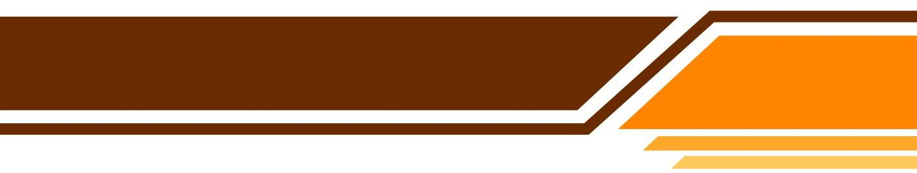Supervisor Signature: _____________________

ZellaTemplate.com